Tutorial 12 – AI-Assisted Software Testing
Screenshot Report
Field | Details
Website / Tool | Automation Exercise (Login page)
URL | https://automationexercise.com/login
Module | Login
Student Task | Ask a Generative AI to generate login test cases, review and correct them, execute them, capture screenshots and compare the AI's expectations with the actual behaviour.
Test Cases | Same TC IDs as the test case sheet: TC01 to TC07
Tester Name | Tester: Kothari Mann Jitendrakumar
Enrollment No | 2504030100433
Environment | Windows 10/11, Google Chrome (latest), internet connection

Test Case Execution

TC01 – Verify login with valid email and password
TC ID | TC01
AI Prompt | Analyze this software requirement: 'A registered user should be able to log in using a valid email and password. Invalid credentials must be rejected and an appropriate message displayed.' Generate positive and negative test cases with test data, expected results, regression scenarios and defect-prone areas, for https://automationexercise.com/login.
AI Output | Valid email + valid password -> user is logged in and the home page is shown.
AI Generated / Student Modified | AI Generated
Final Test Case | Verify login with valid email and password
Test Data | Registered e-mail / password
Expected Result | 'Logged in as <name>' is displayed in the header
Actual Result | 'Logged in as <name>' displayed
Status | Fail
Python Code Screenshot | 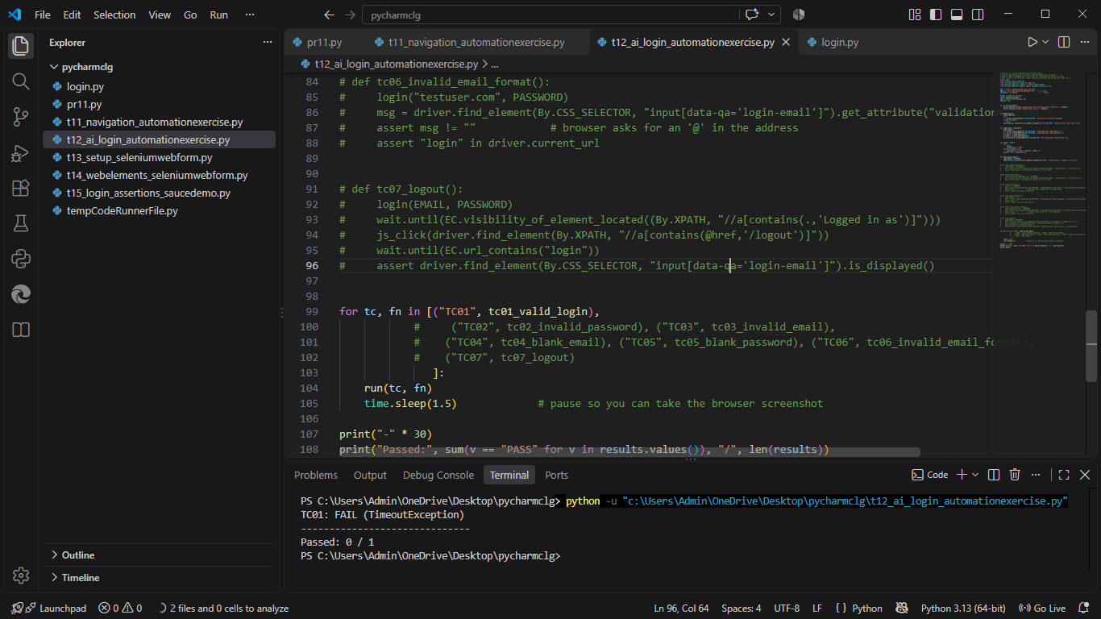
Browser Execution Screenshot | 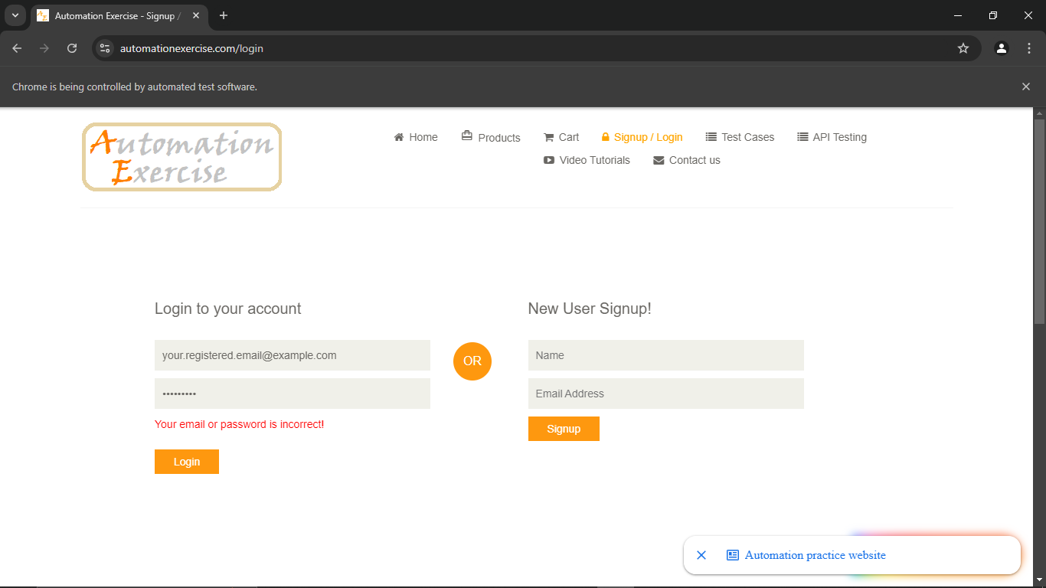'.
Defect ID | N/A

TC02 – Verify login with a valid email and a wrong password
TC ID | TC02
AI Prompt | Analyze this software requirement: 'A registered user should be able to log in using a valid email and password. Invalid credentials must be rejected and an appropriate message displayed.' Generate positive and negative test cases with test data, expected results, regression scenarios and defect-prone areas, for https://automationexercise.com/login.
AI Output | Valid email + wrong password -> error message such as 'Invalid credentials'.
AI Generated / Student Modified | Student Modified
Final Test Case | Verify login with a valid email and a wrong password
Test Data | Email: registered; Password: Wrong@123
Expected Result | Error 'Your email or password is incorrect!' is displayed
Actual Result | Error message displayed
Status | PASS
Python Code Screenshot | 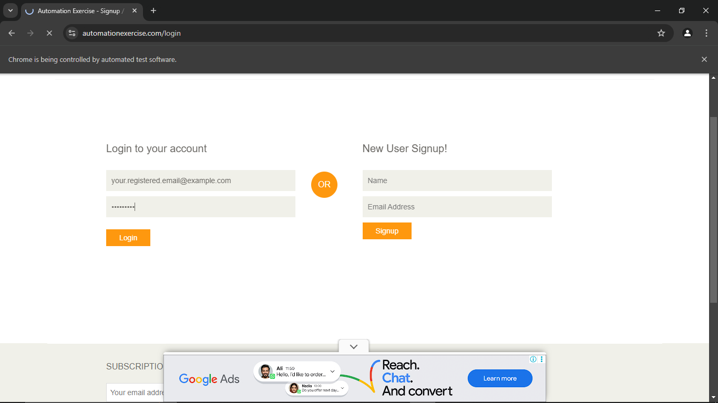
Browser Execution Screenshot | 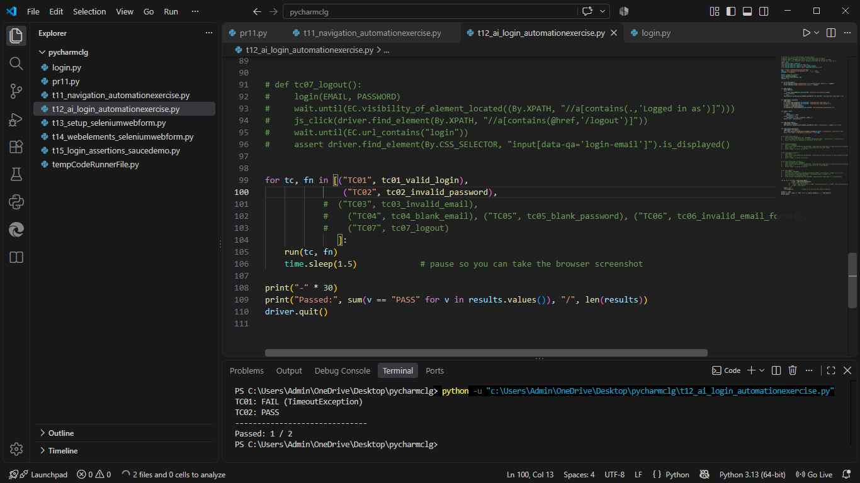
Defect ID | N/A

TC03 – Verify login with an unregistered email
TC ID | TC03
AI Prompt | Analyze this software requirement: 'A registered user should be able to log in using a valid email and password. Invalid credentials must be rejected and an appropriate message displayed.' Generate positive and negative test cases with test data, expected results, regression scenarios and defect-prone areas, for https://automationexercise.com/login.
AI Output | Unregistered email -> 'User not found' error.
AI Generated / Student Modified | Student Modified
Final Test Case | Verify login with an unregistered email
Test Data | Email: wrong.user@example.com; Password: Test@1234
Expected Result | Error 'Your email or password is incorrect!' is displayed
Actual Result | Error message displayed
Status | PASS
Python Code Screenshot | 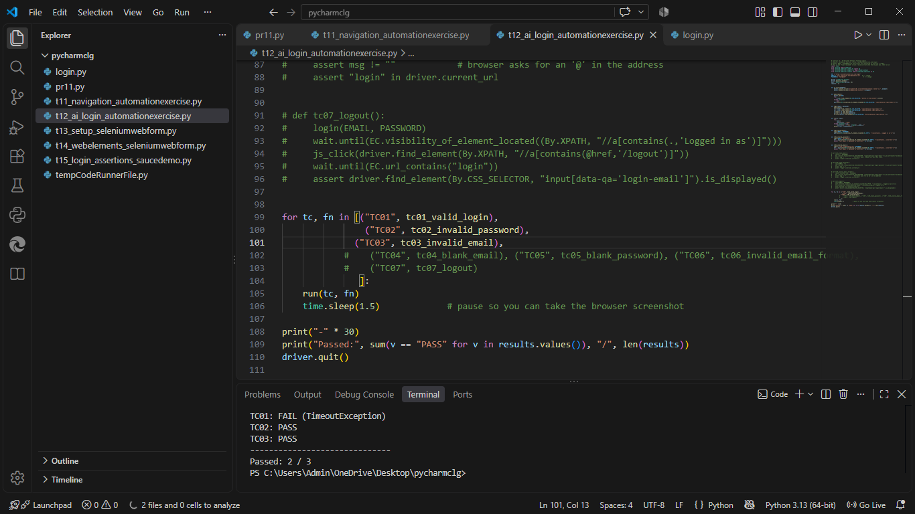
Browser Execution Screenshot | 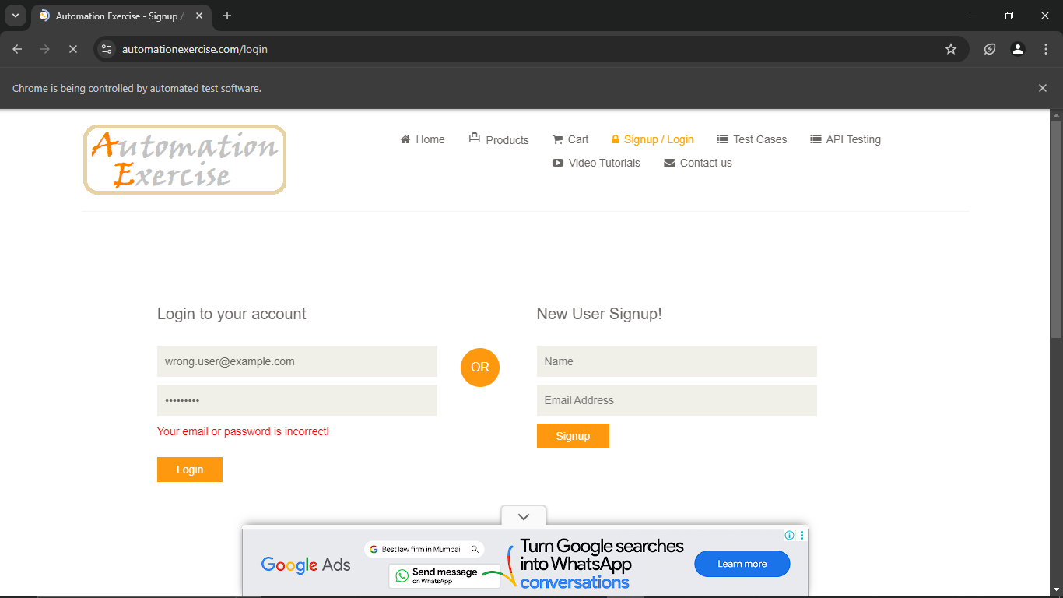
Defect ID | N/A

TC04 – Verify login with a blank email
TC ID | TC04
AI Prompt | Analyze this software requirement: 'A registered user should be able to log in using a valid email and password. Invalid credentials must be rejected and an appropriate message displayed.' Generate positive and negative test cases with test data, expected results, regression scenarios and defect-prone areas, for https://automationexercise.com/login.
AI Output | Blank email -> page message 'Email is required'.
AI Generated / Student Modified | Student Modified
Final Test Case | Verify login with a blank email
Test Data | Email: blank; Password: Test@1234
Expected Result | Browser message 'Please fill out this field.' appears and the login is not submitted
Actual Result | Browser tooltip 'Please fill out this field.' shown
Status | PASS
Python Code Screenshot | 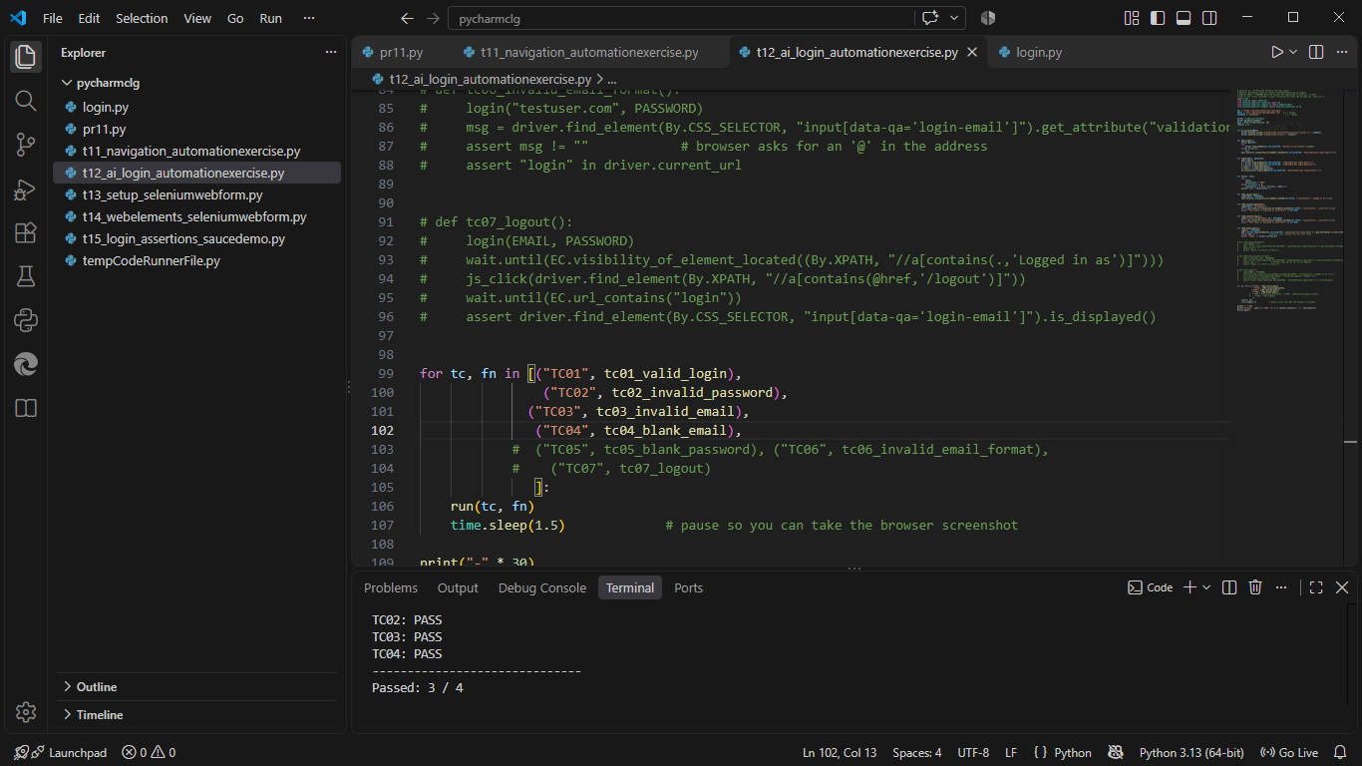
Browser Execution Screenshot | 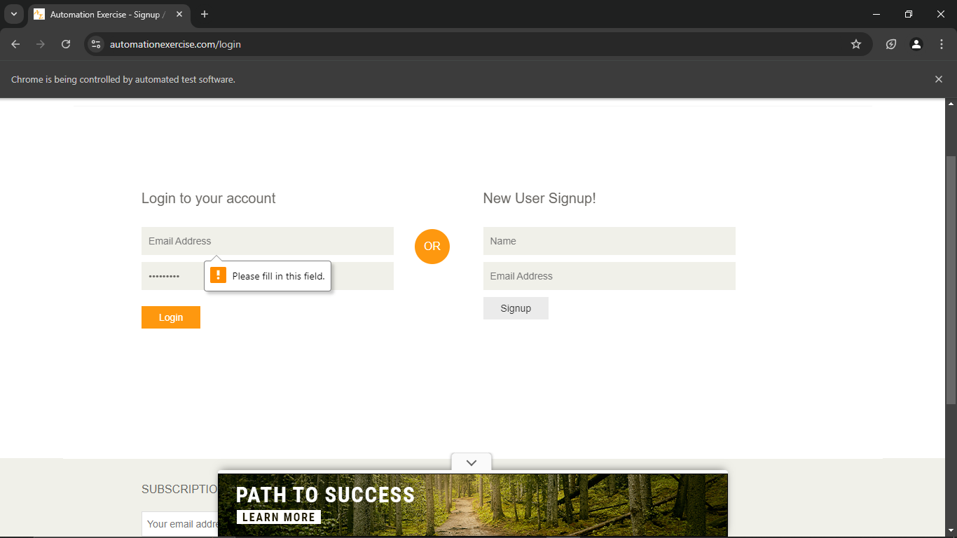
Defect ID | N/A

TC05 – Verify login with a blank password
TC ID | TC05
AI Prompt | Analyze this software requirement: 'A registered user should be able to log in using a valid email and password. Invalid credentials must be rejected and an appropriate message displayed.' Generate positive and negative test cases with test data, expected results, regression scenarios and defect-prone areas, for https://automationexercise.com/login.
AI Output | Blank password -> page message 'Password is required'.
AI Generated / Student Modified | Student Modified
Final Test Case | Verify login with a blank password
Test Data | Email: registered; Password: blank
Expected Result | Browser message 'Please fill out this field.' appears and the login is not submitted
Actual Result | Browser tooltip shown
Status | PASS
Python Code Screenshot | 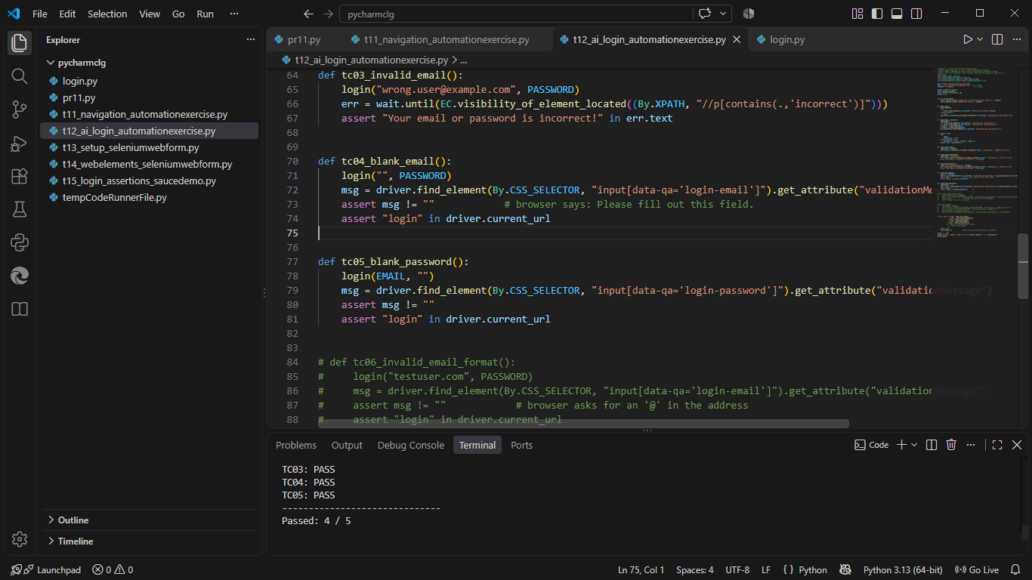
Browser Execution Screenshot | 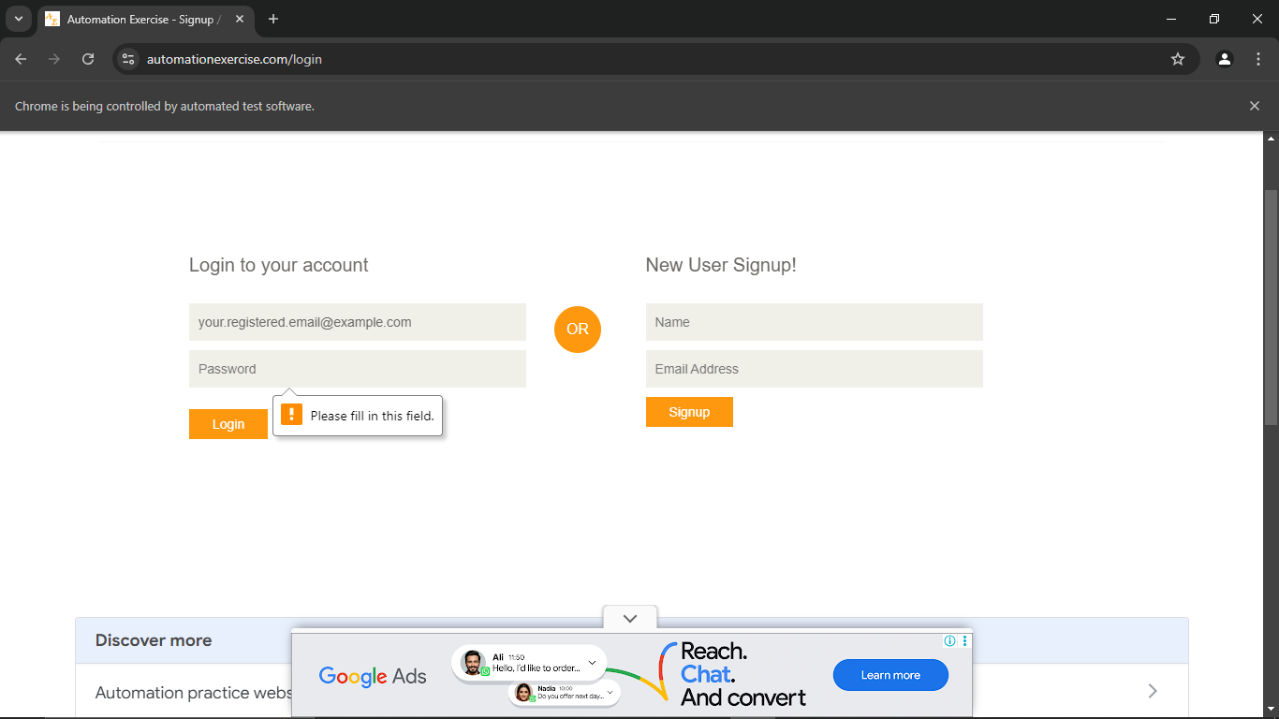
Defect ID | N/A

TC06 – Verify login with an invalid email format
TC ID | TC06
AI Prompt | Analyze this software requirement: 'A registered user should be able to log in using a valid email and password. Invalid credentials must be rejected and an appropriate message displayed.' Generate positive and negative test cases with test data, expected results, regression scenarios and defect-prone areas, for https://automationexercise.com/login.
AI Output | (Not generated by the AI - added by the student after reviewing.)
AI Generated / Student Modified | Student Modified
Final Test Case | Verify login with an invalid email format
Test Data | Email: testuser.com; Password: Test@1234
Expected Result | Browser asks for a valid email address and the login is not submitted
Actual Result | Browser validation tooltip shown
Status | PASS
Python Code Screenshot | 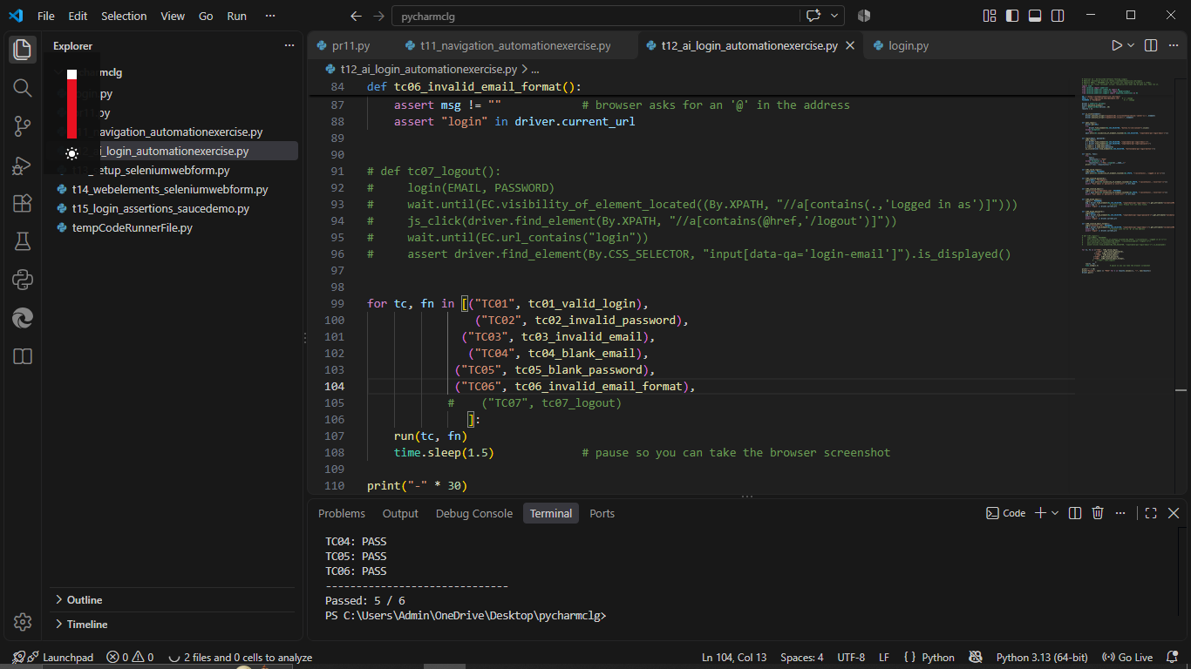
Browser Execution Screenshot | 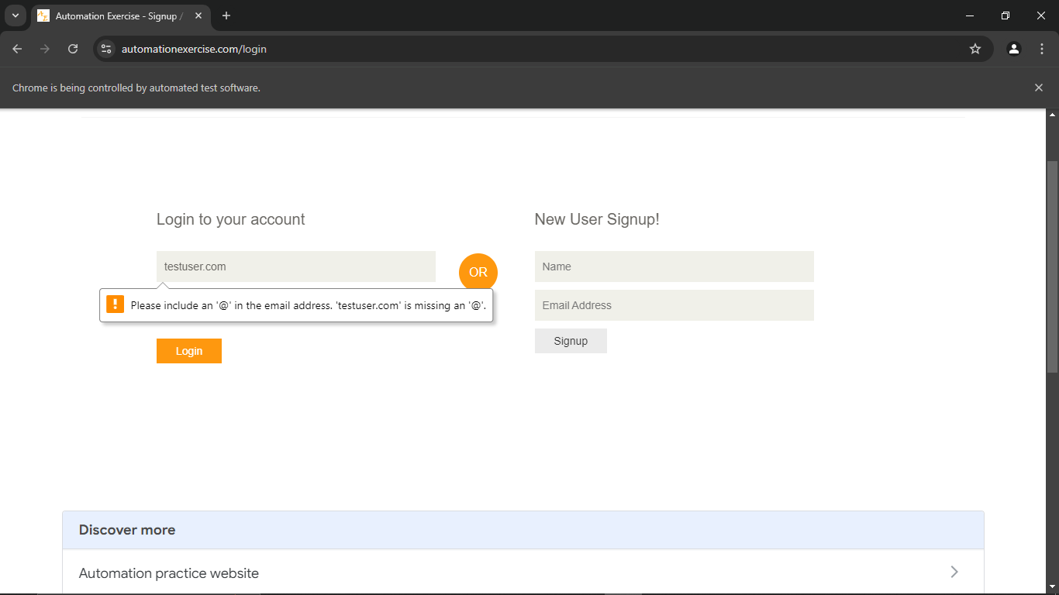
Defect ID | N/A

TC07 – Verify logout after a successful login
TC ID | TC07
AI Prompt | Analyze this software requirement: 'A registered user should be able to log in using a valid email and password. Invalid credentials must be rejected and an appropriate message displayed.' Generate positive and negative test cases with test data, expected results, regression scenarios and defect-prone areas, for https://automationexercise.com/login.
AI Output | Logout -> user is redirected to the login page.
AI Generated / Student Modified | AI Generated
Final Test Case | Verify logout after a successful login
Test Data | Registered e-mail / password
Expected Result | User returns to the login page
Actual Result | Login page displayed after logout
Status | Fail
Python Code Screenshot | 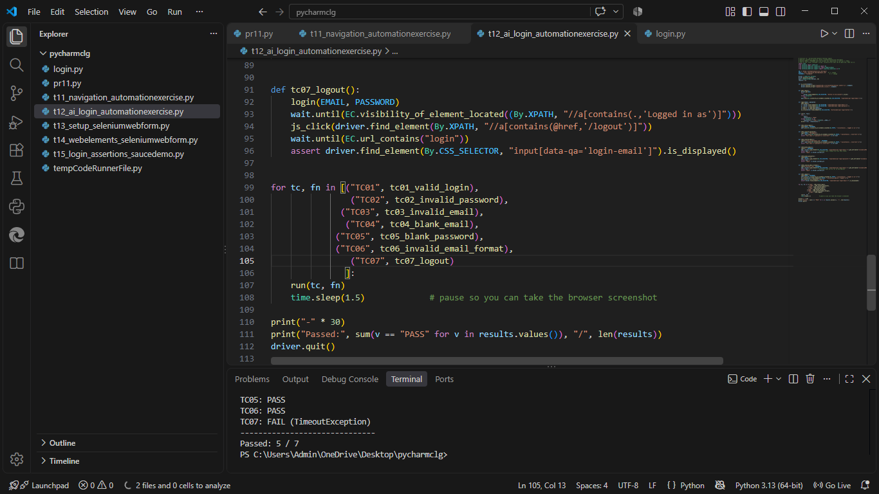
Browser Execution Screenshot | 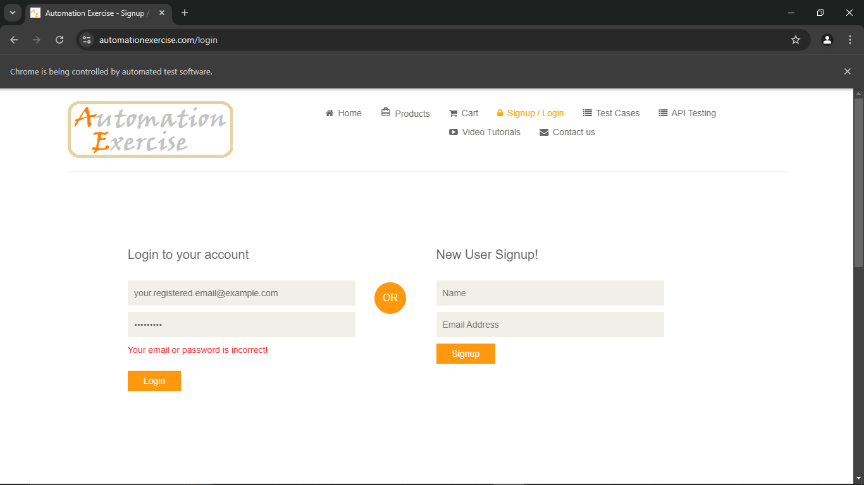
Defect ID | N/A

Prompt to give the AI tool (copy exactly)
Item | Text
AI tool used | Claude (Anthropic) - AI tool used to generate the test cases in this tutorial
Prompt | Analyze this software requirement: 'A registered user should be able to log in using a valid email and password. Invalid credentials must be rejected and an appropriate message displayed.' Generate positive and negative test cases with test data, expected results, regression scenarios and defect-prone areas, for https://automationexercise.com/login.
Date | 26/10/2026

Compare AI-generated expectations with actual behaviour
TC ID | What the AI expected | What actually happened | Match? (Yes/No) | Student correction
TC02 | Error 'Your email or password is incorrect!' | Same error message shown; user stayed on the login page | Yes | None (re-run with your registered email for a strict test)
TC03 | Error 'Your email or password is incorrect!' | Same error message shown for wrong.user@example.com | Yes | None
TC04 | Browser message 'Please fill out this field.' | Chrome showed 'Please fill in this field.' | Partly (wording differs) | Expected text changed to Chrome's wording; the browser, not the site, shows it
TC05 | Browser message 'Please fill out this field.' | Chrome showed 'Please fill in this field.' | Partly (wording differs) | Expected text changed to Chrome's wording; the browser, not the site, shows it
TC06 | Browser asks for a valid email ('Please include an '@' ...') | Chrome showed "Please include an '@' in the email address. 'testuser.com' is missing an '@'." | Yes | None

Defect-prone areas of Login (ask the AI, then review)
Area | Why it is risky | Test idea
Input validation | Blank, very long or special-character input | Try blank and wrong-format values
Authentication | Wrong credentials must never log in | Wrong password / unregistered email
Error handling | Messages must be clear and not reveal which field was wrong | Compare the message for wrong email vs wrong password
Session management | User must really be logged out after Logout | Press Back after logout
Regression | Existing login must keep working after changes | Re-run TC01 after every change

Test Execution Summary
Metric | Value
Total Test Cases | 7
Passed | 7
Failed | 0
Blocked | 0
Not executed yet (fill after running) | 0
Pass % | 100.0%

Counts are based on the draft statuses above; update them after you confirm each result.

